**Project File**

**B.E.(IT) 2nd Semester**



**Submitted To: Submitted By:**

Ms Ritika Pragya Sharma

UE228079

IT Section – 2

**DEPARTMENT OF INFORMATION TECHNOLOGY**

*University Institute of Engineering and Technology,*

*Panjab University,Chandigarh*

Student Management System:

Using GUI in Python.

**CODE:**

from tkinter import*

from tkinter import ttk

class student():

 def __init__(self,root):

        self.root=root#here self is an object of class student

        self.root.title("Student Management Sysytem")

        self.root.geometry("1500x800")

        title=Label(self.root,text="Student Management Sysytem",bd=9,relief="groove",font="cursive 20 bold",bg="black",fg="white")

        title.pack(side="top",fill=X)

        f=Frame(self.root,bd=5,relief=SUNKEN,bg="wheat")

        f.place(y=50,width=505,height=700)

        l1=Label(f,text="Student Info",bg="black",fg="white",bd=4,relief=RAISED,font="sans-serif 20 bold")

        l1.pack()

        l1.grid(row=0,columnspan=2,pady=15)

        name=Label(f,text="Name: ",bg="silver",fg="black",font="lucida 15 bold")

        name.grid(row=1,column=1,sticky="w")

        name_input=Entry(f,font="cursive 20")

        name_input.grid(row=1,column=2,padx=5,pady=7)

        dob=Label(f,text="DOB: ",bg="silver",fg="black",font="lucida 15 bold")

        dob.grid(row=2,column=1,sticky="w")

        dob_input=Entry(f,font="cursive 20")

        dob_input.grid(row=2,column=2,padx=5,pady=7)

        Roll_no=Label(f,text="Roll No: ",bg="silver",fg="black",font="lucida 15 bold")

        Roll_no.grid(row=3,column=1,sticky="w")

        Roll_no_input=Entry(f,font="cursive 20")

        Roll_no_input.grid(row=3,column=2,padx=5,pady=7)

        branch=Label(f,text="Branch: ",bg="silver",fg="black",font="lucida 15 bold")

        branch.grid(row=4,column=1,sticky="w")

        branch_input=Entry(f,font="cursive 20")

        branch_input.grid(row=4,column=2,padx=5,pady=7)

        contactno=Label(f,text="Contact No: ",bg="silver",fg="black",font="lucida 15 bold")

        contactno.grid(row=5,column=1,sticky="w")

        contactno_input=Entry(f,font="cursive 20")

        contactno_input.grid(row=5,column=2,padx=5,pady=7)

        email=Label(f,text="Email Id: ",bg="silver",fg="black",font="lucida 15 bold")

        email.grid(row=6,column=1,sticky="w")

        email_input=Entry(f,font="cursive 20")

        email_input.grid(row=6,column=2,padx=5,pady=7)

        gender=Label(f,text="Gender: ",bg="silver",fg="black",font="lucida 15 bold")

        gender.grid(row=7,column=1,sticky="w")

        gender=ttk.Combobox(f,font="cursive 20",state="readonly")

        gender['values']=("Male","Female","Others")

        gender.grid(row=7,column=2,pady=5,padx=5)

        btn=Frame(f,bd=3,bg="grey",relief="sunken")

        btn.place(x=20,y=500,width=340)

        addbtn=Button(btn,text="Search",width=20).grid(row=0,column=0,padx=6,pady=7)

        addbtn2=Button(btn,text="Reset",width=20).grid(row=0,column=1,padx=10,pady=7)

        d=Frame(self.root,bd=5,relief=SUNKEN,bg="silver")

        d.place(x=505,y=50,width=1000,height=700)

        search=Label(d,text="Search by",bg="black",fg="white",font="lucida 20",relief=GROOVE,width=8)

        search.grid(row=0,column=0,pady=10,padx=20,sticky="w")

        combo=ttk.Combobox(d,font="lucida",state="readonly")

        combo['values']=("Name","Roll no","Branch","CGPA","Email Id")

        combo.grid(row=0,column=1,padx=20,pady=10)

        search_input=Entry(d,font="cursive 20",width=20)

        search_input.grid(row=0,column=2,padx=5,pady=7)

        addbtn3=Button(d,text="Search",width=10).grid(row=0,column=3,padx=2,pady=10)

        # addbtn4=Button(d,text="Show All",width=10).grid(row=0,column=4,padx=2,pady=10)

        t=Frame(d,bd=5,relief=SUNKEN,bg="aliceblue")

        t.place(y=50,width=850,height=630)

        scrollx=Scrollbar(t,orient=HORIZONTAL)

        scrolly=Scrollbar(t,orient=VERTICAL)

        # self.table=ttk.Treeview(t,column=("name","dob","roll","branch","cgpa","email","contact"),xscrollcommand=scrollx.set,yscrollcommand=scrolly.set)

        # scrollx.pack(side=BOTTOM,fill=X)

        # scrolly.pack(side=RIGHT,fill=Y)

        # scrollx.config(command=self.table.xview)

        # scrolly.config(command=self.table.yview)

        # self.table.heading("name",text="Name")

        # self.table.heading("dob",text="DOB")

        # self.table.heading("roll",text="Roll No")

        # self.table.heading("branch",text="Branch")

        # self.table.heading("cgpa",text="CGPA")

        # self.table.heading("email",text="Email Id")

        # self.table.heading("contact",text="Contact No")

        # self.table['show']='headings'

        # self.table.column("name",width=100)

        # self.table.column("dob",width=100)

        # self.table.column("roll",width=100)

        # self.table.column("branch",width=100)

        # self.table.column("cgpa",width=100)

        # self.table.column("email",width=100)

        # self.table.column("contact",width=100)

        # self.table.pack(fill=BOTH,expand=1)

        t1=Label(t,text="Name ",bg="silver",fg="black")

        t1.grid(row=1,column=1)

        t1=Label(t,text="Roll No ",bg="silver",fg="black")

        t1.grid(row=1,column=2)

        t1=Label(t,text="Branch ",bg="silver",fg="black")

        t1.grid(row=1,column=3)

        t1=Label(t,text="CGPA ",bg="silver",fg="black")

        t1.grid(row=1,column=4)

        t1=Label(t,text="Contact No ",bg="silver",fg="black")

        t1.grid(row=1,column=5)

        t1=Label(t,text="Email Id ",bg="silver",fg="black")

        t1.grid(row=1,column=6)

        t1_input=Entry(t,font="cursive 10")

        t1_input.grid(row=2,column=1)

        t1_input=Entry(t,font="cursive 10")

        t1_input.grid(row=2,column=2)

        t1_input=Entry(t,font="cursive 10")

        t1_input.grid(row=2,column=3)

        t1_input=Entry(t,font="cursive 10")

        t1_input.grid(row=2,column=4)

        t1_input=Entry(t,font="cursive 10")

        t1_input.grid(row=2,column=5)

        t1_input=Entry(t,font="cursive 10")

        t1_input.grid(row=2,column=6)

        t1_input=Entry(t,font="cursive 10")

        t1_input.grid(row=2,column=7)

        t2_input=Entry(t,font="cursive 10")

        t2_input.grid(row=3,column=1)

        t2_input=Entry(t,font="cursive 10")

        t2_input.grid(row=3,column=2)

        t2_input=Entry(t,font="cursive 10")

        t2_input.grid(row=3,column=3)

        t2_input=Entry(t,font="cursive 10")

        t2_input.grid(row=3,column=4)

        t2_input=Entry(t,font="cursive 10")

        t2_input.grid(row=3,column=5)

        t2_input=Entry(t,font="cursive 10")

        t2_input.grid(row=3,column=6)

        t2_input=Entry(t,font="cursive 10")

        t2_input.grid(row=3,column=7)

        t2_input=Entry(t,font="cursive 10")

        t2_input.grid(row=4,column=1)

        t2_input=Entry(t,font="cursive 10")

        t2_input.grid(row=4,column=2)

        t2_input=Entry(t,font="cursive 10")

        t2_input.grid(row=4,column=3)

        t2_input=Entry(t,font="cursive 10")

        t2_input.grid(row=4,column=4)

        t2_input=Entry(t,font="cursive 10")

        t2_input.grid(row=4,column=5)

        t2_input=Entry(t,font="cursive 10")

        t2_input.grid(row=4,column=6)

        t2_input=Entry(t,font="cursive 10")

        t2_input.grid(row=4,column=7)

  class student():

    pass

    root=Tk()

    obj=student(root)

    root.mainloop()

**OUTPUT:**

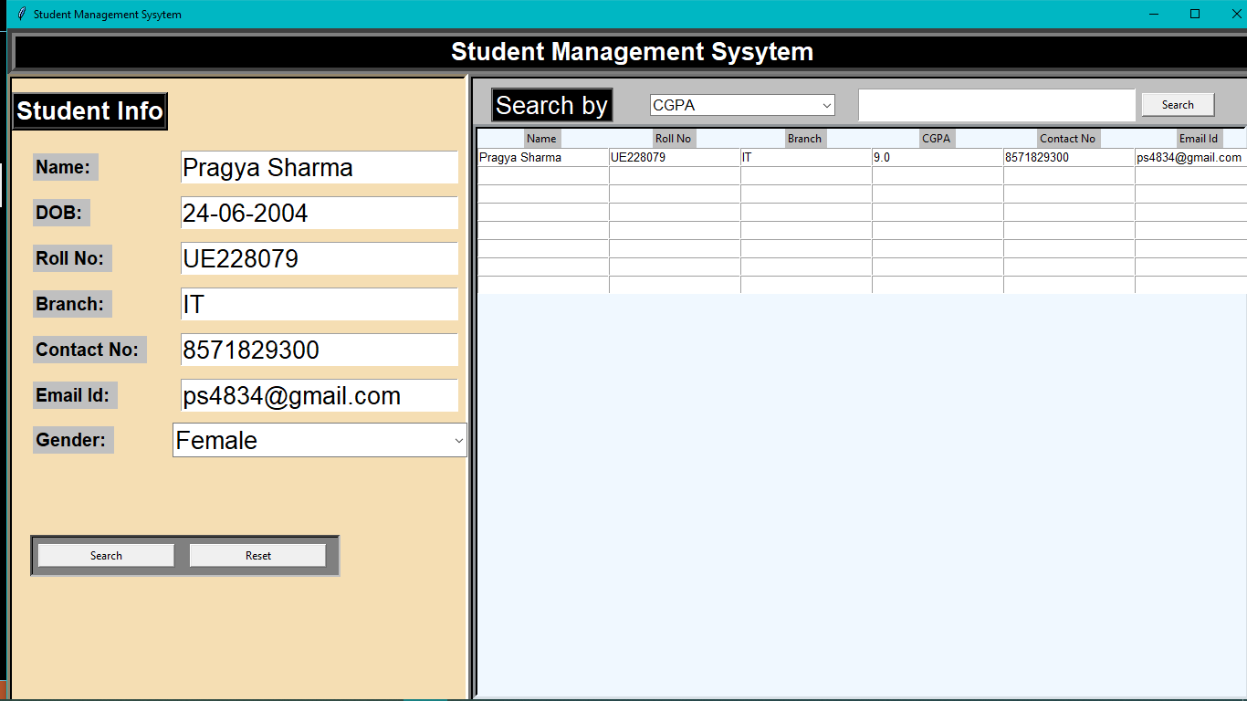

Car Rental System: Using OOPS in C++

**CODE:**

#include<iostream>

#include<iomanip>

using namespace std;

class details{

protected:

string nameofcustomer;

int car_brand;

string car_Number;

};

class rent:public details{

protected:

int rentfee;

int days;

public:

initial();

void greeting();

void data();

void rentamount();

void record();

};

rent::initial(){

rentfee=0;

days=0;

}

void rent::greeting(){

cout<<"\t\t\t~~~~~~~~~~~~~~Welcome To My Car Rental System Project~~~~~~~~~~~~~~~\n";

cout<<"\n\t\t\t\t\t >>>>>>>>>>>>>MADE BY<<<<<<<<<<<<"<<endl;

cout<<"\n\n\t\t\t\t\t--------||Name: "<<"\tPRAGYA SHARMA"<<"-------||"<<endl;

cout<<"\t\t\t\t\t--------||Roll No: "<<"\tUE228079"<<"------||"<<endl;

cout<<"\n\n\t\t\t\t\t\t_____________________"<<endl;

cout<<"\t\t\t\t\t\t| |"<<endl;

cout<<"\t\t\t\t\t\t| |"<<endl;

cout<<"\t\t\t\t\t\t| |___________"<<endl;

cout<<"\t\t\t\t\t\t| |"<<endl;

cout<<"\t\t\t\t\t\t|__-----____________----_______|"<<endl;

cout<<"\t\t\t\t\t\t ( ) ( )"<<endl;

cout<<"\t\t\t\t\t\t________________________________"<<endl;

}

void rent::data(){

cout << "\n\n\t\t\tEnter Customer's Name here: ";

cin >> nameofcustomer;

do{

cout << "\t\t\t\t**********Select a car:-************\n ";

cout << "\t\t\t\t 1.2023 Hyundai Creta"<<endl;

cout << "\t\t\t\t 2.2023 Toyota Urban Cruiser"<<endl;

cout << "\t\t\t\t 3.2023 Maruti Suzuki Ertiga"<<endl;

cout << endl;

cout << "\t\t\t\tPlease Select: ";

cin >> car_brand;

cout << endl;

switch(car_brand){

case 1:

cout<<"\t\t\t \t __________________"<<endl;

cout<<"\t\t\t \t| |"<<endl;

cout<<"\t\t\tYou have selected \t|2023 Hyundai Creta|"<<endl;

cout<<"\t\t\t \t|__________________|"<<endl;

break;

case 2:

cout<<"\t\t\t \t _________________________"<<endl;

cout<<"\t\t\t \t| |"<<endl;

cout<<"\t\t\tYou have selected \t|2023 Toyota Urban Cruiser|"<<endl;

cout<<"\t\t\t \t|_________________________|"<<endl;

break;

case 3:

cout<<"\t\t\t \t _________________________"<<endl;

cout<<"\t\t\t \t| |"<<endl;

cout<<"\t\t\tYou have selected \t|2023 Maruti Suzuki Ertiga|"<<endl;

cout<<"\t\t\t \t|_________________________|"<<endl;

break;

default:

cout<<"\t\t\tSorry!!Car of this brand is unavailable."<<endl;

}

}while(car_brand>3);

}

void rent::rentamount(){

cout<<"\n\n\t\tEnter number of days for which you want the car for rent: ";

cin >> days;

cout<<endl;

if(car_brand == 1)

rentfee = days*300;

if(car_brand == 2)

rentfee = days*350;

if(car_brand == 3)

rentfee = days*250;

}

void rent::record(){

cout<<"\n"<<endl;

cout<<"\t\t ________________ "<<endl;

cout<<"\t\t | |"<<endl;

cout<<"\t\t |CUSTOMER DETAILS| "<<endl;

cout<<"\t\t |________________|"<<endl;

cout << "\n\t\t Customer Name "<<"\t\t\t"<< nameofcustomer<<endl;

cout << "\t\t Car Brand "<<"\t\t\t"<<car_brand<<endl;

cout << "\t\t Number of days(rented) "<<"\t"<<days<<endl;

cout << "\t\t Rental Amount "<<"\t\t"<<rentfee<<endl;

cout << "\n\t\t [Total Rental Amount "<<"= "<<"Rs"<<rentfee<<"]"<<endl;

cout << "\n\n\t\t ****NOTE:\n\t\t\tYou are advised to pay up the amount before due date."<<endl;

cout << "\t\t Otherwise penelty fee will be applied****"<<endl;

cout<<"\n\n\t\t\t\t\t~~~~~~~~~~~~HAPPY JOURNEY!~~~~~~~~~~~~";

}

int main(){

rent r;

r.greeting();

r.data();

r.rentamount();

r.record();

return 0;

}

**OUTPUT:**

